

**Realtime Density Sensor**

Annual Report

2024

# Commercialisation

Upon the completion of the University of Queensland commitment to Phibion’s Innovation Connections grant, the Realtime Density Sensor was left in a non-conclusive state.

Whilst there were some measures of success in understanding the correlation between permittivity of a material and the predicted density, the desired results were not quite as compelling as we had hoped, meaning, there was a lot more development and understanding required.

Both antenna design and analysis method were subjected to an overhaul. This was conducted independently here at Phibion.

Whilst the mechanical characteristics changed significantly, the travel and function of the Vivlaldi Antenna remained unchanged. As for the Operation of the data collection model and machine learning, this significantly changed.

A trial was conducted at a Phibion customer site (Rare Earths) where 2 days of data was collected and married to relative Shear Vane samples. This presented very promising results.

***\*\* These results are illustrated below “Recent Field Trial”***

Unfortunately, further challenges were presented with the Physical attributes which require further attention.

Before progressing to the commercialisation phase, we must complete the following:

* Antenna Housing Design [02/2025]
* Antenna Mounting Bracket Design [02/2025]
* Antenna Electrical Harness Design [03/2025]

# Exploiting License IP (2024)

Phibion have continued to apply time and budget into further developing the Realtime Density Sensor to a marketable product. Phibion has not conducted any operation or exercise that breaches the Licensed IP agreement to date.

# Marketing

Phibion have yet to produce marketing material for the Realtime Density Sensor, however as we draw closer to commercialisation phase, effort will be applied to produce promotional material for this product / service.

# Sub-license Activities

There are zero sub-license activities.

# Recent Field Trial

The results are a combination of two parts:

* Collect values from Density Sensor every 10 seconds
* Collect values from Shear Vanes samples every 10 minutes

The graphics below represent timestamped values with GPS coordinate of both Shear Vane results, Density Sensor predictions.

What can be observed in these images is that the predicted values (right) at depths of 200mm, 500mm & 800mm align very closely with the Shear Vane sample values (left) at the same relative depths. The spectrum of colours are deliberately selected to represent soft to firm relative values.

Very Soft

Soft

Firm

Medium

Extended research is being conducted to seek a correlation / validation means to tie MudMaster performance into the Density Sensor prediction model.

These values include:

* Engine Torque
* Scroll Traction

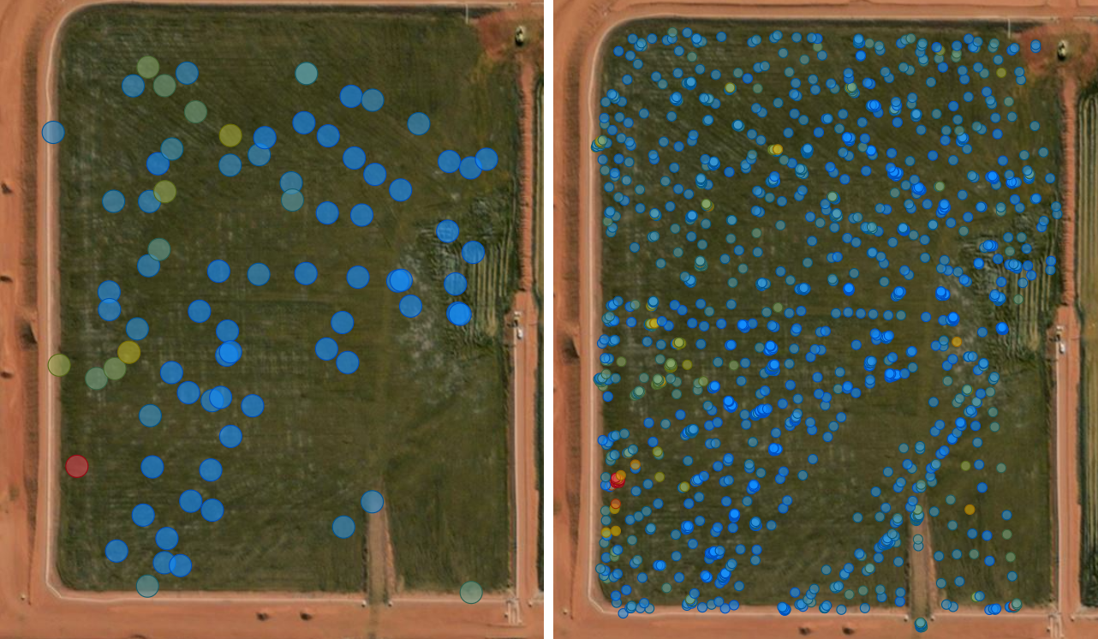

200mm SV values

200mm Predicted values

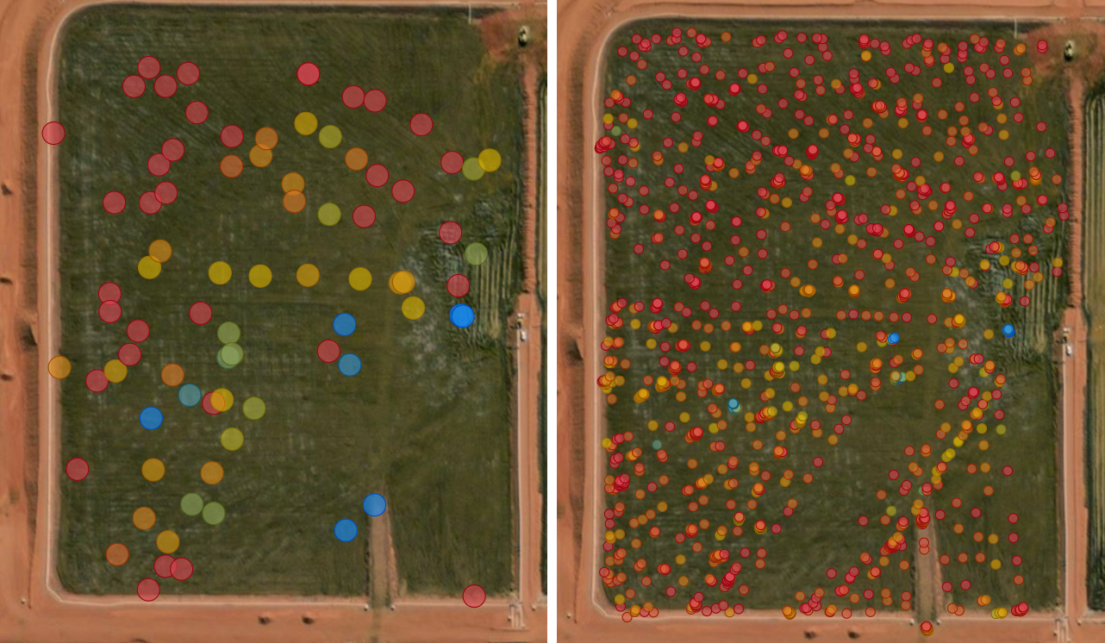

800mm SV values

800mm Predicted values

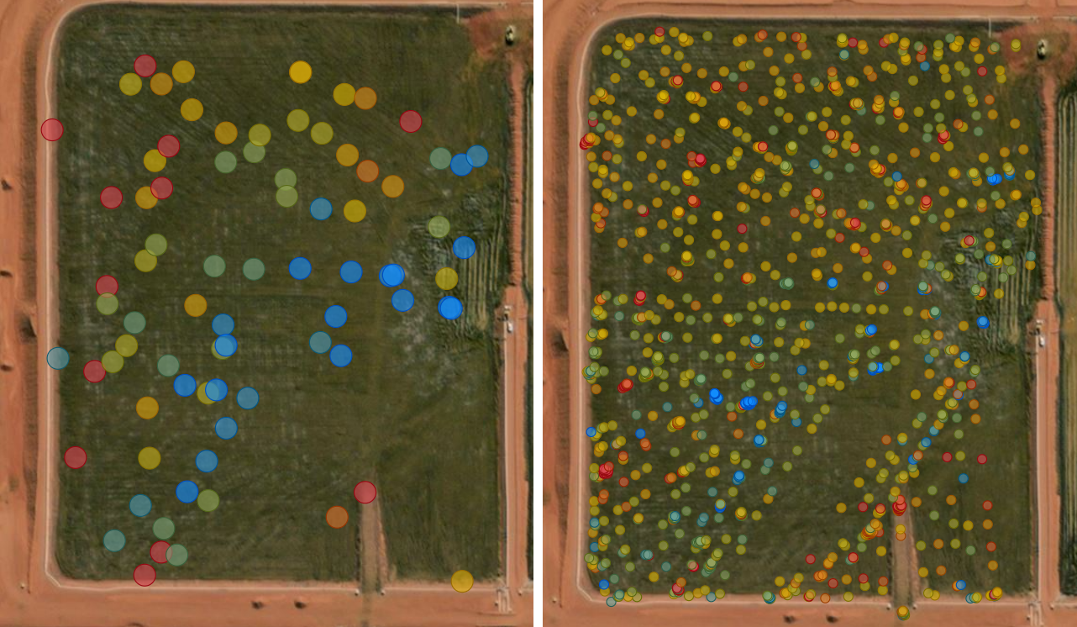

500mm SV values

500mm Predicted values